**epa_logo_vert_medium.tif**

**Point Source Calculator: A Model for Estimating Chemical Concentration in Water Bodies**

Dirk F. Young

Office of Chemical Safety and Pollution Prevention

U.S. Environmental Protection Agency

Washington, D.C. 20460

July 2018

# Abstract

The Point Source Calculator (PSC) is a tool designed to estimate acute and chronic concentrations of chemicals directly applied to water bodies. Waterbodies may include lakes, ponds, or flowing waters like streams and river segments. Direct applications of chemical may be simulated in a flexible manner from simple to complex repetitive events or as completely unique daily events defined on a daily scale. The PSC is a graphical user interface which gathers the user’s inputs and runs USEPA’s Variable Volume Water Model (VVWM). Required inputs are the same as those for the VVWM, but the PSC graphical interface facilitates user interaction for the direct-application problem. Post processing of the PSC is also relevant to the direct-application problem and includes the ability to analyze concentrations in comparison to target *concentrations of concern (CoC)*, including number of days above the CoC and number of consecutive days above the CoC.

# Introduction

The Point Source Calculator (PSC) is a tool for estimating chemical exposure in surface waters from point source discharge(s). The PSC is a user interface that processes input and output for the Variable Volume Water Model (VVWM). The VVWM is used by the USEPA Office of Pesticides for pesticide exposure estimates, typically in conjunction with user interfaces, namely the USEPA Pesticide Water Calculator (PWC) (Fry and Young, 2014) and the Pesticide in Flooded Applications Model (PFAM) (Young, 2012, 2013).

The PSC is like the PWC and PFAM in that it is a user-friendly interface that generates a VVWM input file, runs the VVWM, and processes the data. The PSC, however, is designed to meet the specific need of the Office of Pollution Prevention and Toxics (OPPT), which is to assess chemicals that flow directly into a water body from point source discharges and to compare the modeled surface water chemical concentrations to levels of concern. Thus, the PSC user interface and input and output requirements are different than for PWC or PFAM.

# Conceptual Model

The conceptualization of the processes in the PSC is given by Figure 1. In this conceptualization, the VVWM is used to represent a segment of a water body which receives a direct application of a chemical. The chemical immediately mixes with the water column of the segment. The water column is coupled to a sediment layer and chemical can move into the sediment by a first-order mass transfer process. Chemical can degrade in the water column by user-supplied inputs of hydrolysis, photolysis, and general degradation. Water column chemical can also volatilize according to chemical properties supplied by the user. In the benthic region, the chemical can degrade by hydrolysis and a general benthic degradation rate as supplied by the user. Partitioning to suspended sediment as well as benthic solids occurs according to input values for either an organic carbon portioning linear coefficient (Koc) or a linear sorption coefficient (Kd). A more detailed process description is given in the VVWM documentation in Appendix 1.[[1]](#footnote-1)

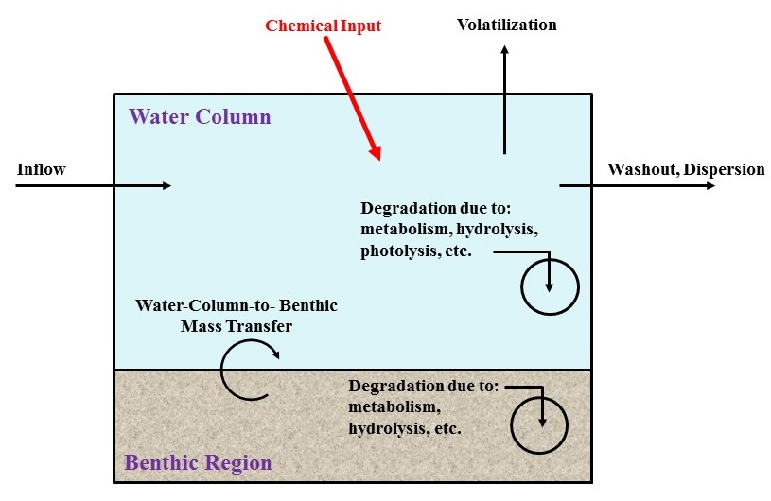

**Figure 1.** Depiction of the chemical processes in the Point Source Calculator.

The waterbodies that can be modeled can be flowing water such as a stream or river or can be more static such as reservoirs or lakes, and the waterbodies can be located anywhere within a watershed as in Figure 2. Figure 2 depicts waterbody segments high in the watershed as for a stream or low towards the exit as for a damned reservoir. In all cases, the waterbody is modeled as a single segment (comprised of a water column and a benthic region), with the appropriate segment being the one that receives the direct application of the chemical (Figure 3). For a static or near-static water body the dimensions should be those of the actual water body averages. For a flowing waterbody the dimensions are the actual width and depth of the water body, while the length should be reflective of the dispersivity (length should equal twice dispersivity) of the flowing body. A good starting value for length of a flowing waterbody may be around 30 meters as estimated from dispersivity data from U.S. rivers and streams (Fisher et al., 1979).

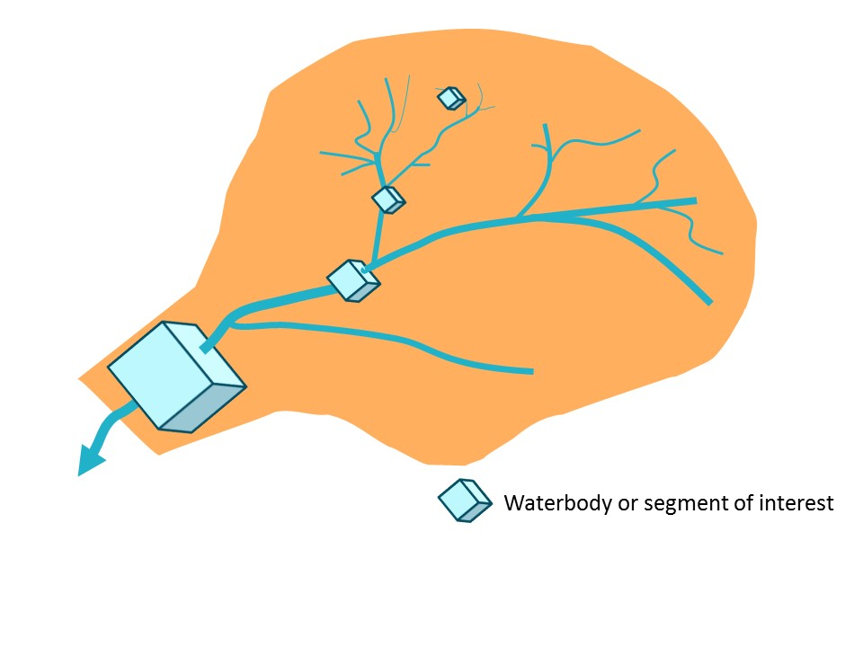

**Figure 2.** Conceptualization of some possible locations of the Pont Source Calculator water body. Waterbodies could be stream segments high in the watershed or large reservoirs at the watershed exit.

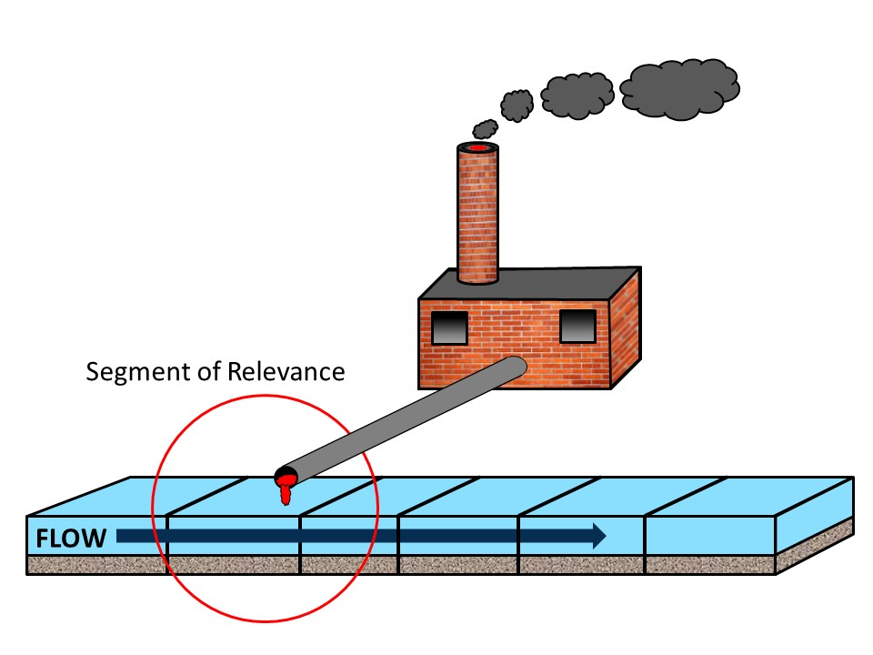

Figure 3. Depiction of the relevant segment of a flowing water addressed by the Point Source Calculator.

Mass inputs into the segment are specified by the user in a variety of ways. Users can specify that chemical mass input occurs according to an on-off schedule, according to a time series file, or as input from a PRZM5 file (Young and Fry, 2014). Users input the appropriate values accordingly as shown in Figure 4 which shows the first tab of the PSC user interface. Description of waterbodies are shown in Figure 5, which is the Scenario tab of the PSC. Details of the various inputs can be found in Appendix 2.

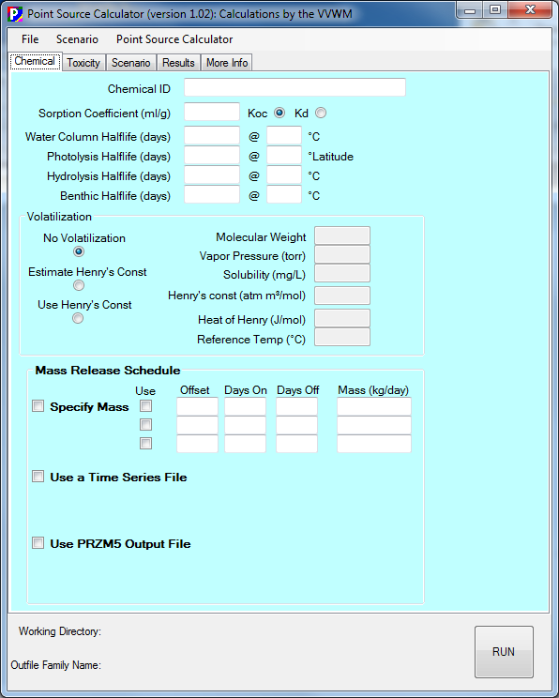

**Figure 4.** Point Source Calculator inputs for chemical properties and mass inputs.

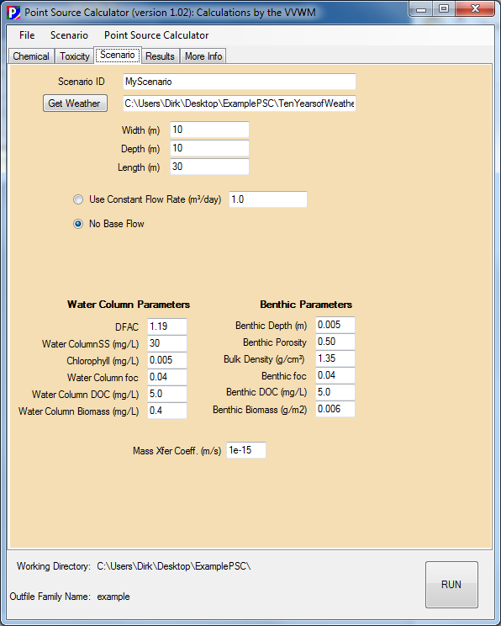

**Figure 5.** Point Source Calculator. Scenario Definition Tab

## Analysis and Post Processing

From the daily concentrations estimated by the PSC, highest acute and chronic values are found and reported to the user interface. Additionally, users may provide *Concentrations of Concern* (CoC) as shown in Figure 6 as points of comparison with the estimated concentrations. The results are given on an output page as shown in Figure 7. A time series graph of water column and benthic pore water concentration is displayed on this tab as well. Additionally, full detailed output files with additional information such as number of consecutive days above the CoC can be found in the output files. Finally, there are additional analyses presented on the last tab as shown in Figure 8. Here theoretical distributions of how the chemical tends to distribute itself in the environment are given, which can indicate which compartments the chemical will tend to be found. Also, the overall long-term average half-lives are given, which is useful for identifying the effective dissipation processes. Fuller descriptions are given in Appendix 2.

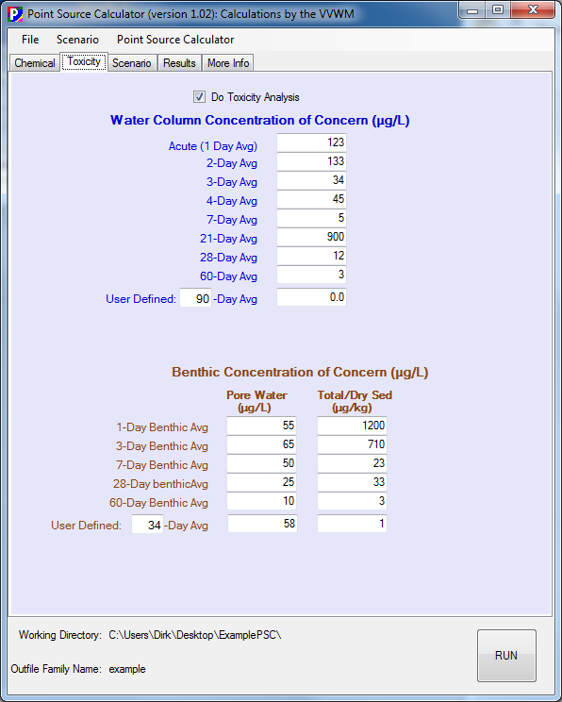

Figure 6. Inputs for Toxicity Analyses.

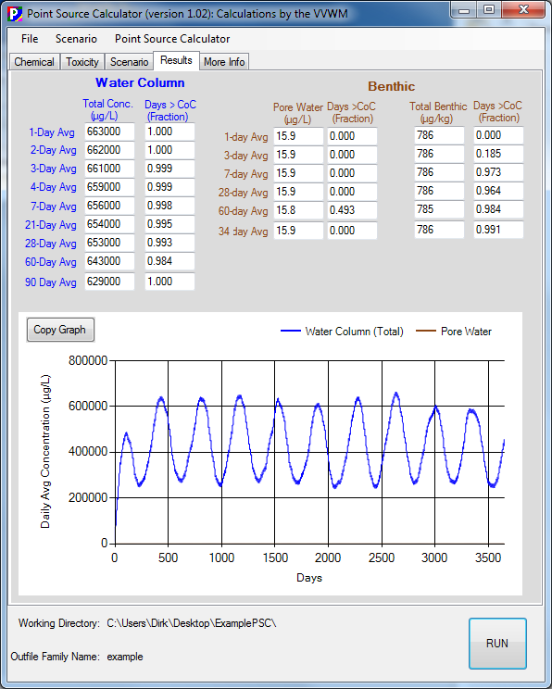

**Figure 7**. Output page of the Point Source Calculator.

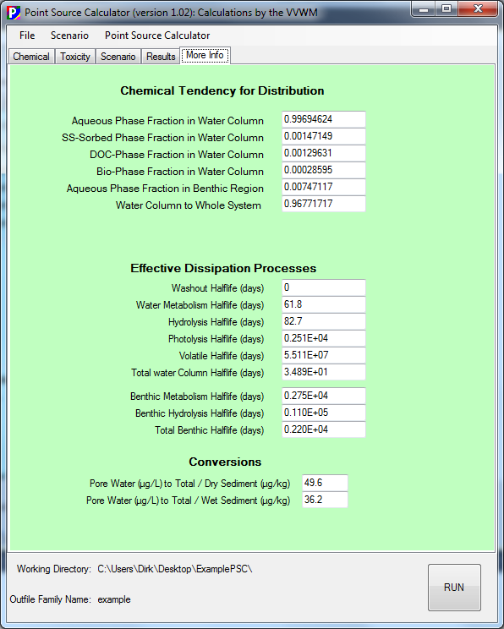

Figure 8. Additional analyses regarding distribution tendency and relative degradation processes.

## References

Fisher, H.B, List, E.J, Koh, R.C.Y., Imberger, J., and Brooks, N.H. (1979) *Mixing in Inland and Coastal Waters*. Academic Press, Ney York, NY. pp. 126-127.

Fry, M.M., Milians, K., Young, D.F., Zhong, H. 2014. *Surface Water Concentration Calculator User Manual*. USEPA/OPP EPA-734-F-14-001. United States EPA, Washington DC.

Young, D.F. 2014. *The Variable Volume Water Model*, EPA-734-F-14-003, United States EPA Washington DC, **DOI:** 10.13140/2.1.3925.7920

Young, D.F. and Fry, M.M. 2014. *PRZM5 A Model for Predicting Pesticide in Runoff, Erosion, and Leachate: User Manual*. EPA-734-F-14-002. United States EPA, Washington DC, **DOI:** 10.13140/2.1.1828.6408

Young,D.F. 2013. *Pesticides in Flooded Applications Model (PFAM): Conceptualization, Development, Evaluation, and User Guid****e***, United States Environmental Protection Agency, Wacshington DC, EPA-734-R-13-001, DOI: 10.13140/2.1.1390.7520

Young, D.F., 2012. Development and Evaluation of a Regulatory Model for Pesticides in Flooded Applications. *Environmental Modeling & Assessment* 17(5), 515-525. DOI: 10.1007/s10666-012-9311-9.

**Appendix 1. The Variable Volume Water Model: Full Documentation**

**epa_logo_vert_medium.tif**

**The Variable Volume Water Model**

**USEPA/OPP 734F14003**

**June 26, 2014**

Dirk F. Young

Environmental Fate and Effects Division

Office of Pesticide Programs

U.S. Environmental Protection Agency

Washington, D.C. 20460

**Contents**

[1 Introduction 1](#_Toc380493482)

[2 The Varying Volume Water Body Model 1](#_Toc380493483)

[2.1 Conceptualization and Mathematics 1](#_Toc380493484)

[2.2 Solute Holding Capacity Ratio (Θ) 5](#_Toc380493485)

[2.3 Effective Water Column Dissipation (Γ1) 6](#_Toc380493486)

[2.3.1 Hydrologic Washout  6](#_Toc380493487)

[2.3.2 Metabolism (μbio\_1) 6](#_Toc380493488)

[2.3.3 Hydrolysis (μhydr\_1) 7](#_Toc380493489)

[2.3.4 Photolysis (μphoto) 7](#_Toc380493490)

[2.3.5 Volatilization (μvolatilization) 8](#_Toc380493491)

[2.4 Effective Benthic Region Dissipation (Γ2) 11](#_Toc380493492)

[2.4.1 Benthic Hydrolysis (μhydr\_2) 11](#_Toc380493493)

[2.4.2 Benthic Metabolism (μbio\_2) 11](#_Toc380493494)

[2.5 Mass Transfer Coefficient (Ω) 12](#_Toc380493495)

[2.6 Daily Piecewise Calculations 14](#_Toc380493496)

[2.6.1 Volume Calculations 14](#_Toc380493497)

[2.6.2 Initial Conditions 14](#_Toc380493498)

[2.7 Analytical Solution 15](#_Toc380493499)

[3 The USEPA Standard Water Bodies 16](#_Toc380493500)

[3.1 Farm Pond 19](#_Toc380493501)

[3.2 Index Reservoir 20](#_Toc380493502)

[3.3 Custom Water Body 20](#_Toc380493503)

[4 VVWM Evaluations 20](#_Toc380493504)

[4.1 Solute Holding Capacity Ratio Sensitivity 20](#_Toc380493505)

[4.2 Washout and Overflow Sensitivity 22](#_Toc380493506)

[4.3 Photolysis Sensitivity 24](#_Toc380493507)

[4.4 Volatilization 26](#_Toc380493508)

[5 Testing and Comparison of VVWM Solution with EXAMS 28](#_Toc380493509)

[6 Computer Program Implementation 29](#_Toc380493510)

[6.1 Executable and the Command Line 29](#_Toc380493511)

[6.2 Input Files 30](#_Toc380493512)

[6.2.1 General Input File 30](#_Toc380493513)

[6.2.2 ZTS Input File 32](#_Toc380493514)

[6.2.3 Meteorological File 33](#_Toc380493515)

[6.3 Output Files 34](#_Toc380493516)

[6.3.1 Regulatory Summary Output File 34](#_Toc380493517)

[6.3.2 Daily Values Output File 34](#_Toc380493518)

[7 Summary 34](#_Toc380493519)

[8 References 35](#_Toc380493520)

**1 Introduction**

USEPA’s Office of Pesticide Programs (OPP) uses computer models to estimate pesticide exposure in surface waters resulting from pesticide applications to agricultural fields. These models are used to simulate pesticide applications to agricultural fields, the subsequent fate and transport in surface waters, and ultimately, estimated environmental concentrations (EECs) that are both protective and scientifically defensible. Using historical meteorological data from the region specified in the risk assessment, PRZM (Carsel *et. al*, 1997) calculates daily runoff and spray drift fluxes from “standard” fields over a simulation period (typically 30 years). These standard fields are parameterized to represent particular crops and regions of the United States (e.g., corn grown in Ohio). Another model EXAMS (Burns, 1985) simulates standard water bodies, that receive pesticides from the standard fields. Because EXAMS is difficult to implement in a user-friendly environment, OPP has created a new program, the Variable Volume Water Body Model (VVWM). VVWM behaves much like EXAMS, simulating the USEPA standard water bodies (i.e., farm pond and index reservoir) but with greater efficiency and flexibility for incorporation into a user interface. The VVWM also allows for variations in water body volume on a daily basis due to runoff, precipitation, and evaporation. Temperature, wind speeds, and pesticide dissipation processes are also allowed to vary daily.

**2 The Varying Volume Water Body Model**

***2.1 Conceptualization and Mathematics***

The VVWM is conceptualized in Figure 1 and consists of two regions: a water column and a benthic region. Each individual region is completely mixed and at equilibrium with all phases in that region, with equilibrium described by a linear isotherm. The two regions are coupled by a turbulent-mixing, first-order mass-transfer process. As Figure 1 also shows, the pond volume may vary by inputs of precipitation and runoff and by outputs of evaporation and overflow.

Conceptual model of the standard water body

**Figure 1. Graphic of the standard water body showing inputs, outputs, and transformation processes.**

The mathematics are solved by daily piecewise analytic solutions. The temporal resolution is one day because daily inputs are readily acquired (i.e., runoff, rainfall, and evaporation data are 24-hour totals), and regulatory needs seldom require finer resolution. The water body volumes and flow rates are also daily values, consistent with the input data resolution. For the analytic solution, water body properties are held constant each day, but may vary from day to day.

All individual dissipation processes (e.g., metabolism, hydrolysis, and volatilization) are represented as first-order in concentration, as described later. On any given day, solute mass in the water body is described by two differential equations, namely a mass balance on the water column:

 (1)

and a mass balance on the benthic region:

 (2)

Where

B = burial rate of sediment, [kg/s]

c1 = aqueous concentration in water column, [kg/ m3]

c2 = aqueous concentration in benthic region, [kg/ m3]

Csed = concentration of suspended sediment in water column = msed\_1/v1 [kg/m3]

CDOC = concentration of DOC in water column = mDOC/v1, [kg/m3]

Cbio = concentration of biota in water column = mbio/v1, [kg/m3]

msed\_1 = mass of suspended sediment in water column, [kg]

mDOC\_1 = mass of DOC in water column, [kg]

mbio\_1 = mass of suspended biota in water column, [kg]

msed\_2 = mass of suspended sediment in water column, [kg]

mDOC\_2 = mass of DOC in benthic region, [kg]

mbio\_2 = mass of biota in benthic region, [kg]

ssed\_1 = sorbed concentration on suspended sediment in water column, [kg/ kg]

sDOC\_1 = sorbed concentration on suspended DOC in water column, [kg/ kg]

sbio\_1 = sorbed concentration on suspended biota in water column, [kg/ kg]

ssed2 = sorbed pesticide concentration on benthic sediment, [kg/ kg]

sDOC\_2 = sorbed pesticide concentration on benthic DOC, [kg/ kg]

sbio\_2 = sorbed pesticide concentration on benthic biota, [kg/ kg]

v1 = volume of water in region 1 on the specific day, [m3]

v2 = volume of water in region 2, [m3]

Q = volumetric flow rate of water out of water column, [m3/s]

α = 1st order water column-to-benthic mass transfer coefficient, [m3/s]

μhydr = 1st order hydrolysis rate coefficient, [s-1]

μphoto =1st order photolysis rate coefficient, [s-1]

μvol = effective 1st order volatilization rate coefficient, [s-1]

μbio\_a1=1st order aqueous-phase metabolic degradation rate coefficient in water column, [s-1]

μbio\_sed1 = 1st order sediment-sorbed metabolic degradation rate coefficient in water column, [s-1]

μbio\_bio1 = 1st order biota-sorbed metabolic degradation rate coefficient in water column, [s-1]

μbio\_DOC1 = 1st order DOC-sorbed metabolic degradation rate coefficient in water column, [s-1]

μbio\_a2 =1st order aqueous-phase metabolic degradation rate coefficient in benthic region, [s-1]

μbio\_sed2 = 1st order sediment-sorbed metabolic degradation rate coefficient in benthic region, [s-1]

μbio\_bio2 = 1st order biota-sorbed metabolic degradation rate coefficient in benthic region, [s-1]

μbio\_DOC2 = 1st order DOC-sorbed metabolic degradation rate coefficient in benthic region, [s-1]

The following assumptions are made: (1) suspended matter in the water column has negligible volume, (2) hydrolysis, photolysis, and volatilization act only on dissolved species, (3) within a single region (water column or benthic), the rate coefficient for biological metabolism is the same for both dissolved and sorbed forms of pesticide (e.g., μbio\_1 = μbio\_a1 = μbio\_sed1 = μbio\_DOC1 = μbio\_biota1, and μbio\_2 = μbio\_a2 = μbio\_sed2 = μbio\_DOC2 = μbio\_biota2), (4) the hydrolysis rate coefficient in the benthic region is the same as that in the water column, (5) linear isotherm equilibrium exists within each region among all sorbed species. With these assumptions, we can rewrite equations (1) and (2) in a simpler form as follows:

 (3)

 (4)

where

 (5)

 (6)

 (7)

 (8)

where fw1 and fw2 are the fractions of solute in the aqueous phase within the water column and benthic regions, respectively, as defined by the following equations:

 (9)

 (10)

and where Ksed\_1, Kbio\_1, KDOC\_1 are the linear isotherm partitioning coefficients for suspended sediments, biota, and DOC in the water column, and Ksed\_2, Kbio\_2, KDOC\_2 are the linear isotherm partitioning coefficients for sediments, biota, and DOC in the benthic region (all with units of m3/kg).

The term, fw1, varies daily depending on the volume of the water body (v1) as described below in *Section 2.6* *Daily Piecewise Calculations*. We assume that the mass of sediment, biota, and DOC remain constant. However, this assumption has very little impact on the model output since partitioning to these species is insignificant, except when given extremely high partitioning coefficients.

Given a set of initial conditions, equations (3) and (4) completely describe the standard water bodies. It is clear that there are only four parameters that influence the concentration—Γ1, Γ2, Ω, and Θ. Γ1 is the effective overall degradation rate in the water column, [s-1]. Γ2 is the effective overall degradation rate in the benthic region, [s-1]. Ω is a mass transfer coefficient describing transfer between the benthic and water column, [s-1]. Θ is the ratio of solute holding capacity in the benthic region to that in the water column, [unitless]. The sections that follow describe the details of the components of these equations with respect to the standard water bodies.

***2.2 Solute Holding Capacity Ratio (Θ)***

The solute holding capacity ratio (Θ) is the ratio of solute holding capacity in the benthic region to the solute capacity in the water column, as defined by equation (8). The individual partitioning coefficients (Kd\_sed, Kd\_biota, and Kd\_DOC) used in equation (8) are generally not directly measured for a pesticide assessment. To account for these unknown coefficients, the standard water bodies use various estimation means that relate the various partitioning coefficients to the organic carbon partitioning coefficient (Koc), which is usually known in a pesticide assessment process.

For the sediment, the partitioning coefficient is directly proportional to Koc, with the constant of proportionality being the amount of organic carbon in the sediment, which is a set to standard values for the standard water bodies (see Table 1). The fraction of organic carbon (foc) is assumed to be the same in the benthic and water column. The sediment partitioning coefficients can thus be determined from the following equation:

 (11)

where Koc = organic carbon partitioning coefficient, [mL/g]

foc = fraction of organic carbon in sediment [unitless]

Note that the units of the coefficients in equations (1) to (10) are all given in *s.i*. form, which is maintained throughout this document. However, for some fundamental parameters such as Koc, which is usually presented in units of mL/g, common units and conversion factors are used.

The partitioning coefficients for DOC are determined from the default empirical relationships described in the EXAMS documentation (Burns, 2000). The VVWM incorporates the notion of Burns (2000) that benthic DOC has higher partitioning characteristics than water column DOC for standard water bodies:

 (12)

 (13)

The partitioning coefficients for biota are also determined from default empirical relations described in the EXAMS documentation:

 (14)

By inserting equations (11) through (14) into equation (8) and substituting specific values from Table 1 into equation (8), the solute holding capacity (Θ) can be written as a function of solely Koc, as presented in Figure 2 for both the standard pond and reservoir.

***2.3 Effective Water Column Dissipation (Γ1)***

The overall dissipation rate in the water column (Γ1), as defined in equation (5) is the sum of contributions from hydrologic washout and degradation by mechanisms of biological metabolism, photolysis, and hydrolysis. The specific methods and assumptions that are used in the VVWM to determine these individual first-order dissipation processes are described below.

**2.3.1 Hydrologic Washout **

The first term in equation (5), Q/v1, represents the effective first-order dissipation rate due to flow moving pesticide out of the water body. Flow out of the water body only occurs if meteorological conditions produce enough water inflow to cause the water body to overflow (see *Section 2.6 Daily Piecewise Calculations*). The washout term acts on all forms of pesticide (aqueous dissolved and sorbed to suspended matter), as is apparent from equation (1) and the definitions for Xsed, Xbio, and XDOC. This means that the settling of suspended solids is not explicitly considered in the VVWM, and pesticides in both dissolved and suspended sorbed forms can flow out of the reservoir.

Flow is obtained from an input file or entered as a constant baseflow. The input file provides a daily flow and is typically generated by the PRZM model as a zts file (see section 6.22) Baseflow will work is additive to any flow from the zts file.

**2.3.2 Metabolism (μbio\_1)**

In the registration process of pesticides, an estimate of the aqueous degradation rate under aerobic conditions is supplied by the registrant. Such estimates are derived from laboratory tests following standard EPA-approved protocols, which are typically conducted in aqueous/sediment systems at 20 to 25° C. These tests generally do not differentiate between degradation occurring on the dissolved and sorbed forms of the pesticide; an overall degradation rate is generally all that is available. Therefore, the VVWM treats the sorbed-phase and aqueous-phase degradation rates as the same, which makes both equal to the overall rate.

As temperature varies in a water body, the USEPA has established a standard for temperature adjustments of the aerobic metabolism rate when regulating pesticides as follows:

 (15)

where μ25 = laboratory measured aerobic metabolism rate at 25°C, [s-1]

T = temperature of modeled water body, [°C]

Tref = temperature at which laboratory study was conducted, [°C]

This temperature adjustment doubles the metabolism rate for every 10°C rise in temperature, and halves the rate for every 10°C decrease. Air temperature is taken from the meteorological data that corresponds to the crop/location scenario being simulated. The VVWM uses the previous 30-day average temperature and adjusts the temperature daily. (Note: EXAMS made temperature adjustments on a monthly calendar basis, which required tracking of the Gregorian calendar).

**2.3.3 Hydrolysis (μhydr\_1)**

The hydrolysis rate is directly obtained from experimental measurements, as supplied by pesticide registrant data submissions. In the VVWM, the effective hydrolysis rate is the experimentally-determined overall hydrolysis rate from tests conducted at the pH of interest. In a typical USEPA assessment, the pH is 7 (Note: Because pH is not included explicitly in the VVWM, the appropriate input is the overall hydrolysis rate, not the specific neutral-, base-, or acid-catalyzed hydrolysis rate coefficients, as in EXAMS).

Unlike the metabolism rate, temperature adjustments of the hydrolysis rate are not made by the VVWM. Temperature-dependent hydrolysis characterizations are not generally made for the registration process, and the USEPA has not adopted a standard adjustment for temperature effects on hydrolysis. Therefore, the hydrolysis rate is as follows:

 (16)

where μoverall, pH = laboratory-measured overall hydrolysis rate at pH of interest, [s-1].

The VVWM uses the assumption that hydrolysis acts only on dissolved species. Therefore, the effective hydrolysis rate is reduced by the fraction of total pesticide that is present in dissolved aqueous form (fw1), as defined in equation (9) and implemented in equation (5).

**2.3.4 Photolysis (μphoto)**

Photolysis rates are derived from standard laboratory tests following USEPA-approved protocols. These tests are designed to estimate the photodegradation rate for near-surface conditions at a specific latitude and under clear-sky conditions. The VVWM adopts the methods given by EXAMS (Burns 1997, 2000) to account for latitude adjustments, light attenuation, and cloud cover:

 (17)

where flat = latitude adjustment factor, [unitless]

fcloud = cloudiness adjustment factor, [unitless]

fatten = attenuation factor to absorption, [unitless]

μmeasured = measured near-surface photolysis rate coefficient at reference latitude and clear atmospheric conditions [sec-1]

Although cloudiness does not affect the current standard water bodies (fcloud is set to a standard value of 1), fcloud is included here for the purposes of formality and because it may be considered in future versions.

The latitude of the standard water body varies, depending on the desired location in the U.S. where the pesticide assessment is being made. The effect that latitude has on incident light is accounted for by the latitude adjustment factor (flat), which the VVWM adopts from EXAMS (Burns, 2000). Full details of the reasoning behind flat can be found in the EXAMS documentation, and only the resulting equation is given here:

 (18)

where Lref = reference latitude at which the measured photolysis rate was determined, [degrees]

Lsim = latitude of the simulated scenario, [degrees]

The light attenuation factor (fatten) described by Burns (2000) has also been adopted; the full details are available in the EXAMS documentation:

 (19)

where Dfac = EXAMS-defined distribution factor default value = 1.19, [unitless]

d1 = depth of water column, [m]

a = total absorption coefficient, [m-1]

The absorption coefficient (a) is calculated from EXAMS default conditions—that is, from the spectral absorption coefficient assuming that the wave length of maximum absorption occurs at 300 nm:

 (20)

where CDOC, CSed have been previously defined under equation (1), and CCHL is the chlorophyll concentration [mg/L].

Temperature effects are not considered in the above equations, except when the water temperature is 0°C or below. Photolysis is inhibited, as in EXAMS. Temperature effects are not considered since the USEPA generally does not receive temperature dependent data for the registration process and has not adopted a standard temperature adjustment for photolysis.

**2.3.5 Volatilization (μvolatilization)**

The VVWM uses a two-film model for volatilization calculations and all of the default volatilization assumptions as described in the EXAMS documentation (Burns, 2000). The concentration of a pesticide in the atmosphere is assumed to be negligible, and thus volatilization becomes a first-order dissipation process. The overall volatilization rate coefficient is expressed as follows:

 (21)

where A = surface area of water column, [m2]

kvol = volatilization exchange coefficient, [m/s]

and the volatilization exchange coefficient comprises liquid-phase and gas-phase resistances:

 (22)

where kw = liquid-phase resistance [m/s]

ka = gas-phase resistance, [m/s]

H = Henry’s law constant (m3atm/mol)

R = the universal gas constant (8.206 x 10-5 m3atm/mol/K)

T= temperature (K)

The VVWM uses the EXAMS methods of referencing the liquid exchange resistance of pesticides to the liquid resistance of oxygen, and uses molecular weight as the sole surrogate for molecular diffusivity variations among compounds. Further details can be found in the EXAMS documentation (Burns, 2000), but the resulting relationship is as follows:

 (23)

where kO2 = oxygen exchange constant at 20°C, [m/s]

MW = molecular weight of pesticide, [g/mol]

The oxygen exchange constant is determined from the empirical relationship of Banks (1975). Adjustments are also made for temperatures other than 20°C. Note that although EXAMS uses a reference temperature of 20°C for the Banks (1975) relationship, it is not clear from Banks (1975) what the actual reference temperature should be. Schwarzenbach et al. (1992) used a 10°C reference for the same relationship. Until further clarified, a 20°C reference temperature is used. For wind velocities (vwind) less than 5.5 m/s, kO2 is calculated as:



(24)

and for wind velocities greater than or equal to 5.5 m/s, kO2 is:

 (25)

where u10 = wind velocity at 10 m above water surface [m/s].

Wind speeds measured at 10 m above the surface are read from the meteorological files. To convert to wind speeds at a different height, the following equation is used:

 (26)

where z0 is the boundary roughness height, which is assumed to be 1 mm for the standard water bodies. Given a wind speed (measured at 10 m) from the meteorological file, the equivalent wind speed at 0.1 m is:

 (27)

In the VVWM, wind speed varies on a daily basis, unlike in EXAMS where the average monthly wind speed varies on a monthly basis.

The gas-phase resistance is referred to as water vapor resistance, and an empirical relationship based on a linear regression of laboratory-derived data from Liss (1973) relates the water vapor exchange velocity to wind speed:



where ka,H2O = the water vapor exchange velocity (m/s)

u0.1 = wind speed velocity measured at 0.1 m above the surface (m/s)

The exchange rate of a pesticide is then related to the exchange rate of water by:

 (28)

where α (not to be confused with the alpha in equation 1 and 2) is a value that depends on the conceptual model believed to describe volatilization and ranges from 0.5 for the surface renewal model to 1.0 for the stagnant film model (Cusler,1984 ; Schwarzenbach et al., 1993). The VVWM uses a value of 1.0 for α; thus, implying a stagnant film model. However, some laboratory data suggest that α may be better represented with a value of 0.67 (Mackay and Yuen, 1983). The diffusion coefficient of the pesticide is related to the diffusion coefficient of water by the common approximate relationship (e.g., Schwarzenbach et al., 1993):

 (29)

Substituting (29) into (28) gives:

 (30)

The resulting relationship is:

 (31)

The Henry’s Law constant is generally not available from pesticide registration submissions, so it is approximated in the VVWM from vapor pressure and solubility. The Henry’s Law constant also is not adjusted for temperature, as this information is not supplied in the pesticide registration, and OPP has not adopted a standard temperature adjustment factor. The resulting relationship is:

 (32)

where vp = vapor pressure [torr]

Sol = solubility [mg/L]

***2.4 Effective Benthic Region Dissipation (Γ2)***

The overall benthic degradation in the VVWM, as defined in equation (6), is only affected by biodegradation and hydrolysis. As with the water column, OPP assumes that biodegradation in the benthic region affects all forms of pesticide (both dissolved and sorbed forms) and that hydrolysis affects only aqueous dissolved forms (see equation 6 and definition of fw2).

**2.4.1 Benthic Hydrolysis (μhydr\_2)**

In the current standard water bodies, the pH of the entire system (benthic and water column) are held at a constant pH of 7, although a subsequent paper will suggest using scenario-specific pH values. Benthic hydrolysis is assumed to occur at the same rate as hydrolysis in the water column; the previous discussion of hydrolysis in the water column applies to the benthic region:

 (33)

**2.4.2 Benthic Metabolism (μbio\_2)**

In the VVWM, benthic metabolism is assumed to occur under anaerobic conditions. Therefore, anaerobic metabolism rates are derived from laboratory tests following standard EPA-approved protocols. These studies are typically conducted in aqueous/sediment systems at 20 - 25°C. As with water column metabolism, OPP assumes that sorbed-phase degradation occurs at the same rate as aqueous-phase degradation, and temperature effects on metabolism are handled in the same way. Thus, the effective rate is the following:

 (34)

where μmeasured = laboratory measured anaerobic metabolism rate at Tref

T = temperature of modeled water body [°C]

Tref = temperature at which anaerobic laboratory study was conducted [°C].

***2.5 Mass Transfer Coefficient (Ω)***

The mass transfer coefficient (Ω) defined in equation (7) is an overall coefficient that includes all means of pesticide exchange between the water column and benthic regions. This includes exchange through the aqueous phase as well as by mixing of sediments between the two compartments. The physical process of this combined mixing is assumed to be completely described by a first-order mass transfer coefficient (α). The parameter α is referenced to the aqueous phase, but implicitly includes exchange due to mixing of sediments as well as aqueous exchange. In compartment modeling, it is unnecessary to explicitly model the individual exchange mechanisms (as EXAMS does) since all phases of pesticide within a compartment are at equilibrium. Therefore, the concentration of a pesticide in any given form (aqueous or sorbed) dictates the concentration of the other forms of the pesticide.

In the VVWM, the α term is based upon parameters and assumptions given in the EXAMS documentation. Although not explicitly presented as such, EXAMS uses a boundary layer model to exchange pesticide mass between the water column and benthic regions. EXAMS defines the parameter DSP, which represents a Fickian-type dispersion coefficient in the benthic sediment. This dispersion coefficient acts on the total concentration within the benthic region, implying that sediment-sorbed pesticide moves through the benthic region at the same rate as dissolved-phase pesticide (e.g., via bioturbation). The rate of mass change in the benthic region is approximated under steady state conditions across a boundary layer of constant thickness:

 (35)

where M2 = total pesticide mass in benthic region

A = area of benthic/water column interface, [m2]

D = effective overall dispersion coefficient in benthic media (includes both sorbed and

dissolved phases), [m2/s]; DSP in EXAMS

Δx = thickness of boundary layer, [m]

 = total partition coefficient for total concentrations, [unitless]

CT1 = total concentration in water column, [kg/m3]

CT2 = total concentration in benthic region, [kg/m3]

The total concentrations in the water column and benthic regions are calculated as follows:

 (36)

 (37)

where c1 and v1 are the aqueous-phase concentration and the aqueous volume, as previously defined under equation (1); Σ(m1Kd1) and Σ(m2Kd2) are short-hand notation for the sum of all solid masses and the respective Kds presented under equation (1) for the water column and benthic regions, respectively; VT1 and VT2 are the total volumes of the water column and benthic region, respectively, which include both the water and the solids volumes. The total pesticide mass in the benthic region is expressed as follows:

 (38)

The total partitioning coefficient is defined as the ratio of CT2 to CT1 when the system is at equilibrium:

 (when benthic region is at equilibrium with water column) (39)

By substituting in the definitions of CT1 and CT2 from equations (36) and (37) and recognizing that at equilibrium c1 = c2, the total partitioning coefficient becomes:

 (40)

Substituting equations (36) to (40) into equation (35) yields the following:

 (41)

Comparing equation (41) with equation (2), we can see that:

 (42)

and that Ω is:

 (43)

where D = overall water column -to-benthic dispersion coefficient (m2/s)

Δx = boundary layer thickness (m)

A = area of water body (m2)

D in the above equation is set to a constant (Table 1) for the USEPA standard pond. The value of D was originally chosen to be on the order of Fickian-type dispersion coefficients in sediments, as observed in field studies reported in the EXAMS documentation. Although equation (42) implies a mechanistic meaning to α, it is difficult to adequately transform Fickian-type dispersion coefficients into first-order mass transfer coefficients for finite volume compartments, and it is equally difficult to define a boundary layer thickness, especially when there is sediment and aqueous mixing. EXAMS suggests that the boundary layer thickness be equal to the distance between the center of the water column and the center of the benthic region, but the actual boundary layer thickness is difficult to estimate and likely is more related to benthic animal life than water column depth.

Attempting to model the benthic mass transfer parameter as a function of water column depth would be speculative, so the VVWM currently maintains a constant thickness.

***2.6 Daily Piecewise Calculations***

Because we retain an analytical solution, the VVWM is solved in a daily piecewise fashion, in which the volume of the water column changes at the beginning of the day and remains constant for the duration of that day. Mass is conserved in the water column by recalculating a new beginning day concentration with any volume change.

**2.6.1 Volume Calculations**

The volume of the water column aqueous phase is calculated from daily runoff, precipitation, and evaporation for any day as follows:

 for 0 < v1 < vmax (44)

where v0 = the aqueous volume of the previous day (m3)

R = daily runoff into the water body (m3)

P = daily direct precipitation on water body (m3)

E = daily evaporation of runoff (m3)

S = daily seepage = 0 (neglected) (m3)

Daily runoff is taken from the PRZM model output. Daily precipitation and evaporation are taken from the meteorological file. Seepage at this time is not considered, as in EXAMS. If the newly calculated volume (v1) is greater than vmax, then the volume for the day is set to vmax, and the excess water is used in the calculation of washout. The minimum water volume is zero, but it is set to an actual minimum to prevent numerical difficulties associated with calculations involving infinity and zero. There also may be some practical physical lower boundary appropriate for the minimum volume, such as those associated with soil water holding capacity, water tables, and refilling practices of pond owners. These factors need to be explored further.

**2.6.2 Initial Conditions**

Initial concentrations are determined by the pesticide mass inputs from PRZM and spray drift. PRZM gives daily outputs for pesticide mass associated with aqueous-phase runoff and erosion solids. All of the pesticide in aqueous-phase runoff and half of the pesticide associated with the erosion solids are delivered to the water column, and the remaining half of solids-associated pesticide is delivered to the benthic region. Pesticide may also be delivered to water bodies by spray drift, which is delivered solely to the water column. In addition, pesticides may also exist in the water bodies from previous inputs. For the VVWM, there is an instantaneous volume change at the beginning of the day due to hydrologic conditions (*Section 2.6.1* *Volume Calculations*); thus the concentration in the water column is adjusted accordingly. The initial concentrations, upon addition of new pesticide mass, are then expressed as follows:

 (45)

 (46)

where Mrunoff = mass of pesticide entering water body via runoff (kg)

Merosion = mass of pesticide entering water body via erosion (kg)

Mdrift = mass of pesticide entering water body via spray drift (kg)

C10,prior = aqueous concentration in water column before new mass additions (kg/m3)

C20,prior = aqueous concentration in benthic region before new mass additions (kg/m3)

v1, prior = the water column volume from the previous day (m3)

fw1,prior = fw1 from the previous day

Xd = fractional initial distribution (between water column and benthic region) of the pesticide associated with eroded solids as it enters the water body

***2.7 Analytical Solution***

Equations (3) and (4) along with the initial conditions represent the two equations describing the standard water bodies. These equations are in the form of the following:

 (47)

 (48)

where









Equations (47) and (48) have the solution:

 (49)

 (50)

where









Average concentrations can be determined over any interval in which all parameters remain constant. In the VVWM, parameters change on a daily basis, so the average water column concentration is expressed as follows:

 (51)

where C1,avg = average water column concentration of time from t1 to t2 [kg/m3]

t1 = beginning of the time interval considered [s-1], (zero for our case of daily estimates)

t2 = end of the time interval considered [s-1], (86,400 seconds for our case of daily estimates)

**3 The USEPA Standard Water Bodies**

All parameters in the above equations, except for the pesticide-specific parameters, have standard values set by the USEPA for the standard farm pond and index reservoir scenarios (Table 1). Many of these values have no documentation and simply have evolved over many years of repeated, unquestioned use. Table 2 shows how the parameters in the VVWM simplify and replace previous EXAMS parameters and expressions, and Table 3 lists the original EXAMS standard parameters. The VVWM also gives the option to define a custom-sized water body.

**Table 1. Standard Parameter Values for the VVWM.**

|  |  |  |  |  |
| --- | --- | --- | --- | --- |
| **Parameter** | **Units** | **Farm Pond Values** | **Index Reservoir Values** | **Notes** |
| v1 | m3 | 20,000 | 144,000 | water column volume |
| v2 | m3 | 249.8 | 1,314 | aqueous benthic volume(a) |
| A | m2 | 10,000 | 52,555 | surface area, calculated (v1/d1) |
| d1 | m | 2.0 | 2.74 | water column depth |
| d2 | m | 0.05 | 0.05 | benthic depth |
| msed\_1 | kg | 600 | 4,320 | based on suspended solids concentration of 30 mg/L (see Csed\_1) |
| mbio\_1 | kg | 8.0 | 57.60 | based on biota concentration of 0.4 mg/L |
| mDOC\_1 | kg | 100 | 720 | based on DOC concentration of 5 mg/L |
| foc | — | 0.04 | 0.04 | fraction of organic carbon (water column and benthic) |
| msed\_2 | kg | 6.752 x 105 | 3.552 x 106 | (b) |
| mbio\_2 | kg | 0.0600 | 0.3156 | (c) |
| mDOC\_1 | kg | 1.249 | 6.570 | (d) |
| pH |  | 7 | 7 |  |
| CCHL | mg/L | 0.005 | 0.005 | chlorophyll concentration |
| CDOC | mg/L | 5 | 5 | DOC concentration |
| Csed\_1 | mg/L | 30 | 30 | suspended solids concentration |
| Cbio | mg/L | 0.4 | 0.4 | biomass concentration |
|  |  |  |  |  |
| D | m2/s | 8.33 x 10-9 | 8.33 x 10-9 | sediment dispersion coefficient |
| Δx | m | 1.02 | 1.39 | benthic/water column boundary layer thickness |
| VT2 |  | 500 | 2,630 | total volume of benthic region (d1 x A) |

(a) calculated from: VOL2\*BULKD\*(1.-100./PCTWA)

(b) calculated from: (BULKD)(VOL2)(100000)/PCTWA (see Table 2)

(c) calculated from: BNMAS\*AREA\*.001(see Table 2)

(d) calculated from: DOC\*v2/1000

**Table 2. VVWM Equivalents of EXAMS Parameters.**

|  |  |  |
| --- | --- | --- |
| VVWM Parameters | | Expressed in Terms of EXAMS Parameters |
| m1 | [kg] | (SUSED)(VOL1) (10-3) |
| m2 | [kg] |  |
| v1 | [m3] | VOL1 |
| v2 | [m3] | \* |
| Q | [m3/s] | STFLO (3600 s/hr) |
| μA1 | [s-1] | (KBACW1)(BACPL)/(3600s/hr) |
| μS1 | [s-1] | (KBACW2)(BACPL)/(3600s/hr) |
| μA2 | [s-1] |  |
| μS2 | [s-1] |  |
|  | [s-1] |  |
| Kd1 | m3/kg | (KOC)(FROC)(10-3 m3/L) |
| Kd2 | m3/kg | (KOC)(FROC)(10-3 m3/L) |

\*Assumes that the density of water is 1,000 kg/m3

**Table 3. EXAMS Standard Parameters.**

|  |  |  |  |
| --- | --- | --- | --- |
| EXAMS Parameter | | EXAMS Value for Standard Pond | EXAMS Value for Standard Drinking Water Reservoir |
| PRBEN | — | 0.5 | 0.5 |
| PCTWA | — | 137 | 137 |
| BULKD | g/mL | 1.85 | 1.85 |
| FROC | — | 0.04 | 0.04 |
| CHARL | m | 1.05 |  |
| DSP | m2/hr | 3.00 x 10-5 | 3.00 x 10-5 |
| AREA | m2 | 10000 | 52600 |
| VOL1 | m3 | 20,000 | 144,000 |
| VOL2 | m3 | 500 | 2,630 |
| DEPTH1 | m | 2 | 2.74 |
| SUSED | mg/mL | 30 | 0.005 |
| CHL | mg/L | 0.005 | 0.005 |
| DOC1 | mg/L | 5.0 mg/L | 5.0 mg/L |
| DOC2 | mg/L | 5.0 mg/L | 5.0 mg/L |
| LAT |  | 34 | 39.1 |
| BNMAS | g/m2 | 0.006 | 0.006 |
| BNBAC1 | -- | -- | -- |
| BNBAC2 | cfu/100g | 37 | 37 |
| BACPL1 | cfu/mL | 1 | 1 |
| BACPL2 | — | -- |  |
| DFAC | — | 1.19 | 1.19 |
| WIND | m/s | metfile | metfile |
| STFLO | m3/hr | 0 | Average daily rainfall (from 36 years of data) |
| TCEL | °C | monthly avg | monthly avg |

***3.1 Farm Pond***

The standard farm pond, representing a highly vulnerable exposure scenario, is a pond located at the edge of a pesticide-treated field. The pond dimensions (1 ha area by 2 m depth), originally based on a Georgian farm pond size, are in accordance with USDA guidance for pond construction for an appropriately-sized pond fed by a 10-ha watershed—that is, approximately 2 acres of drainage per acre-ft of storage in central Georgia (USDA, 1982). In the farm pond, where inflow is assumed to exactly balance evaporative losses (leaching is not modeled). Table 1 gives some of the standard parameters for the pond.

***3.2 Index Reservoir***

The index reservoir represents a natural or artificial lake fed by perennial and ephemeral streams, varying in flow due to precipitation, evaporation, and runoff from the surrounding watershed and groundwater discharge. The reservoir is a potential drinking water source that may be affected by pesticide runoff, spray drift, and leaching to groundwater. The reservoir is a fixed volume water body with outflow equated to runoff that enters the reservoir. Table 1 gives some of the standard parameters for the index reservoir.

***3.3 Custom Water Body***

A custom water body also can be defined in the VVWM with specific dimensions, including the field area [m2], water body area [m2], initial depth [m], maximum depth [m], and hydraulic length [m]. The custom water body can be of varying volume, or of constant volume with (or without) flow through. This third option allows for greater flexibility in evaluating pesticide fate and transport in a non-standard receiving water body.

**4 VVWM Evaluations**

***4.1 Solute Holding Capacity Ratio Sensitivity***

As Figure 2 shows, the standard index reservoir has a lower solute holding capacity ratio than the standard pond, and this is due to the greater water column depth of the reservoir. The point where Θ is equal to 1 represents the Koc for which the solute capacity in the benthic region is equal to that in the water column. For the pond, equal capacities occur at Koc of 730 mL/g, and for the reservoir, the equal capacities occur at 1,000 mL/g. Of course, the water column and benthic regions are not at equilibrium, so the actual distribution of solute will not be evenly split between benthic and water column at these Koc values. These values and Figure 2, however, give some physical insight into how the standard water bodies can potentially distribute solute.

It is also of interest to examine the relative significance of the individual media within each region with regard to the distribution of solute among them. Figure 3 shows the relative capacities of the individual media (aqueous and sorbed to biota, DOC, and suspended sediment) within the water column as a function of Koc. Up to a Koc value of ~10,000 mL/g, only the water phase is significant. Up to Koc values of 100,000, biota partitioning is not significant, and at a Koc value of 100,000, the combined capacities of all sorbed species amounts to less than 20 percent of the total water column capacity. It can also be seen that, for the standard water bodies, DOC and suspended sediments have nearly equal capacities for solute.

Figure 4 shows the relative capacities for the benthic region. For the benthic region of the standard water bodies, DOC and biota partitioning are not significant at any Koc value; the relative fractions for DOC and biota are on the order of 10-7 to 10-5, which cannot be seen in the Koc range shown (Figure 4). At a Koc of about 9 mL/g, solute is evenly distributed between the pore-water-dissolved fraction and the sediment-sorbed fraction. At Koc values above 1,000 mL/g, the vast majority of solute in the benthic region is sorbed to sediment.

Solute holding capacity as a function of Koc

**Figure 2. Solute holding capacity as a function of Koc for the USEPA standard water bodies.**

Relative solute holding capacity of components in water column

**Figure 3. Relative solute holding capacity of individual components in water column.**

Relative solute holding capacity of components in benthic layer

**Figure 4. Relative solute holding capacity of individual components in benthic region.**

***4.2 Washout and Overflow Sensitivity***

Figures 5 and 6 show how the VVWM overflow modification affects pesticide dissipation in the standard pond and standard reservoir, respectively. The effective dissipation half-life due to washout of a pesticide is shown for a range of typical annual average runoff flow rates as determined from OPP’s standard scenarios. This figure only gives an idea of the potential long-term effect of the VVWM washout addition. Short-term effects will be quite variable since washout is calculated on a daily basis, and during overflow events, the effective half-life may differ greatly from long-term averages.

Washout halflife as a function of flow rate for a water body the size of the USEPA standard pond.

**Figure 5. Effective half-life of pesticide due to washout in the standard pond as currently parameterized (1 hA area, 2 m deep). Range of flow rates are for the current standard field size (10 hA).**

Washout halflife as a function of flow rate for a water body the size of the USEPA standard reservoir.

**Figure 6. Effective half-life of pesticide due to washout in the standard reservoir as currently parameterized (5.26 hA, 2 m deep). Range of flow rates are for the current standard field size (10 hA).**

***4.3 Photolysis Sensitivity***

With the above considerations, the effective photolysis rate in the standard water bodies only depends on the laboratory-measured photolysis rate, the latitude of the water body, and the reference latitude of the measured photolysis rate. The effective photolysis rate can be written in terms of these parameters. For the farm pond, the effective rate is calculated from the following equation:

 (52)

Values for the standard water bodies are given in Table 1. Given the values for standard water bodies in Table 1(a = 42.096 m-1); fatten = 0.009981 for the farm pond; fatten = 0.007286 for the reservoir; and *flat* =s 0.804 for 34°.

From equation (52) for a standard farm pond at latitude of 34° and with a reference laboratory latitude of 0°, the effective aqueous-phase photolysis rate is 124 times lower than the measured laboratory rate. For the standard reservoir at the same latitude, the rate is 170 times less than the laboratory determined value. As with hydrolysis, photolysis is assumed to act upon only dissolved forms of pesticide; therefore, the overall effective hydrolysis rate is further reduced by the factor fw in equation (5).

A plot of the inverse of equation (52) shows its effect on the half-life as given in Figure 7. This figure shows that depth is nearly proportional to the increase in half-life at the scale shown. A closer look at depth in Figure 8 shows that the direct proportional relationship begins at about 0.02 m, indicating that the photolysis has fully attenuated by this depth. Further increases in half-life are simply due to the greater amount of volume in the water column.

Photolysis sensitivity with depth of water body

**Figure 7. The effect of depth on the effective half-life due to photolysis, showing the almost proportional linear relationship of half-life with depth.**

Photolysis sensitivity with depth of water body: small scale depths

**Figure 8. Smaller scale depth figure, showing that reductions in photolysis half-life become proportional (linear) with depth after about 0.02 m.**

***4.4 Volatilization***

The effect that wind speed has on effective half-life is given in Figure 9 for the standard pond. The figure shows that wind speed variations will have an increasingly dramatic effect as Henry’s law coefficient is reduced. The use of daily wind speeds in the VVWM thus has significant short-term implications (acute concentrations) for low Henry’s law compounds.

Volatilization as calculated by the VVWM is relatively insensitive to changes in temperature because OPP has not adopted a temperature adjustment standard for the Henry’s Law coefficient and volatilization data (as a function of temperature) required for registration. Thus, OPP currently assumes that the Henry’s Law coefficient is constant regardless of temperature.

Sensitivity of volatilization half life to wind speed and Henrys' Law constant

**Figure 9. Effect of Henry’s Law Constant and wind speed (measured at 6m) on effective volatilization half-life of aqueous phase. MW= 100, Temp = 25 °C.**

Sensitivity of volatilization half life to temperature (excluding effects of temperature on and Henrys' Law constant)

**Figure 10. Effect of Henry’s Law Constant and temperature on effective volatilization half-life of aqueous phase. The lack of temperature sensitivity is a result of not considering the effect of temperature on Henry’s Law Constant. Wind speed = 1 m/s, MW=100.**

Comparison of the volatilization between VVWM and EXAMS

**Figure 11. Comparison of the volatilization mechanisms of the VVWM and EXAMS for conditions: solubility = 100 mg/L, MW=100, vapor pressure = 0.1 torr, Koc = 1 mL/g, wind speed = 1 m/s, temperature = 25o C, and an input mass of 0.02 kg to the water column. A constant volume condition was used for the VVWM.**

**5 Testing and Comparison of VVWM Solution with EXAMS**

Individual processes of the VVWM analytical solution were tested by comparing the output with that of EXAMS. For these tests, a constant volume condition was imposed on the VVWM, so that only the processes common to both EXAMS and the VVWM were tested. Individual processes were tested by either zeroing out all other dissipation or making them insignificant, and using a single initial aqueous-phase input. The results from a test of the volatilization routine are shown in Figure 11. Here the analytical solution for volatilization in the VVWM is captured and correctly formulated. Other processes such as hydrolysis, photolysis, metabolism, and benthic mass transfer were tested in a similar manner, and all tested equally well. Combined processes with multiple inputs, including spray drift, erosion, and runoff, as read from PRZM output files, were also tested. An example is given in Figure 12, which shows excellent agreement with EXAMS, and further verifies the proper formulation of the processes within the VVWM.



VVWM

**Figure 12. Comparison of VVWM with EXAMS for the following conditions: MW = 100, solubility = 100 mg/L, vapor pressure = 0.01 torr, aerobic half-life = 10 days, anaerobic half-life = 100 days, Koc = 100 mL/g, wind speed = 1 m/s, temperature = 25 °C, and arbitrarily selected PRZM input fluxes. A constant volume condition was used for the VVWM.**

**6 Computer Program Implementation**

***6.1 Executable and the Command Line***

Running the VVWM requires the executable and three input files: a general input file, a “ZTS” file, and a meteorological file. The executable is run from a command line with the following command:

**fortranvvwm.exe “*inputfilename”***

where *fortranvvwm.exe* is the name of the executable, and *inputfilename* is a command line argument that specifies the path and name of the **General Input File**. For example,

C:\> fortranvvwm.exe “C:\My Documents\Test\MyFirstInputFile.txt”

In this case, the fortranvvwm.exe file is located on the C: directory and the input file is named MyFirstInputFile.txt and located in the C:\My Documents\Test\ directory. Note: Quotation marks around the command line argument are necessary if there are any blank spaces in the argument.

***6.2 Input Files***

**6.2.1 General Input File**

The input file is a text file with the structure given in Table 4. For lines that hold multiple inputs, the data is separated by a comma or space. The first line specifies where additional input will be read and where the output will be delivered.

**Table 4. General Input File Format.**

|  |  |  |  |
| --- | --- | --- | --- |
| Line | **Fortran Variable Name** | **Type** | **Description** |
| 1 | output filename | character(256) | Full path and name of main output file (less suffix). This establishes the base name and location of the output files.  This also specifies the name of the \*.zts file that will be read for the mass and water flow. This input file must be named *outputfilename*.zts where *outputfilename* is the string defined by the variable outputfilename. |
| 2 | UNUSED |  |  |
| 3 | nchem | integer | 1 = parent only, 2 = parent and degradate, 3= parent, degradate 1, degradate 2 (sequential) |
| 4 | is\_koc | logical | Establishes whether the sorption coefficient is Koc or Kd; True = Koc , False = Kd |
| 5 | koc\_all(i) | real | Sorption coefficient (mL/g); the number of values should match nchem |
| 6 | aer\_aq\_all(i) | real | Water column degradation half-life (days); the number of values should match nchem |
| 7 | temp\_ref\_aer\_all(i) | real | Reference temperature for water column degradation; the number of values should match nchem |
| 8 | anae\_aq\_all(i) | real | Benthic degradation half-life (days); the number of values should match nchem |
| 9 | temp\_ref\_anae\_all(i) | real | Reference temperature for benthic degradation; the number of values should match nchem |
| 10 | photo\_all(i) | real | Photolysis half-life (days); the number of values should match nchem |
| 11 | RFLAT\_all(i) | real | Reference latitude for photolysis; the number of values should match nchem |
| 12 | hydro\_all(i) | real | Hydrolysis half-life (days); the number of values should match nchem |
| 13 | UNUSED |  |  |
| 14 | UNUSED |  |  |
| 15 | UNUSED |  |  |
| 16 | MWT(i) | real | Molecular Weight; the number of values should match nchem |
| 17 | VAPR\_all(i) | real | Vapor Pressure (torr); the number of values should match nchem |
| 18 | SOL\_all(i) | real | Solubility (mg/L); the number of values should match nchem |
| 19 | xAerobic(i) | real | Molar Conversion Factor for water column degradation; the number of values should match (nchem-1): parent to degradate 1, degradate 1 to degradate 2 |
| 20 | xBenthic(i) | Real | Molar Conversion Factor for benthic degradation; the number of values should match (nchem-1): parent to degradate 1, degradate 1 to degradate 2 |
| 21 | xPhoto(i) | Real | Molar Conversion Factor for photolysis; the number of values should match (nchem-1): parent to degradate 1, degradate 1 to degradate 2 |
| 22 | xHydro(i) | real | Molar Conversion Factor for hydrolysis; the number of values should match (nchem-1): parent to degradate 1, degradate 1 to degradate 2 |
| 23 | UNUSED |  |  |
| 24 | UNUSED |  |  |
| 25 | UNUSED |  |  |
| 26 | UNUSED |  |  |
| 27 | UNUSED |  |  |
| 28 | QT | real | Q10 factor by which degradation increases for every 10 °C rise in temperature. |
| 29 | scenario\_id | Character(50) | Text to describe the field scenario. Used for naming output files. |
| 30 | metfilename | Character(256) | Full path and file name of the meteorological file. |
| 31 | UNUSED |  |  |
| 32 | UNUSED |  |  |
| 33 | UNUSED |  |  |
| 34 | burialflag | logical | If set to .TRUE. this will activate pesticide removal by sediment burial. |
| 35 | UNUSED |  |  |
| 36 | UNUSED |  |  |
| 37 | UNUSED |  |  |
| 38 | UNUSED |  |  |
| 39 | D\_over\_dx | real | Mass transfer coefficient (m/s) as defined by D/Δx in Eqn . 46 |
| 40 | PRBEN | real | Xd in equation 40 and 41 |
| 41 | benthic\_depth | real | Depth of benthic region (m) |
| 42 | porosity | real | Porosity of benthic region (--) |
| 43 | bulk\_density | real | Bulk density of benthic region (g/mL). Mass of solids per total volume. |
| 44 | FROC2 | real | Fraction of organic carbon on sediment in benthic region. |
| 45 | DOC2 | real | Concentration of dissolved organic carbon in benthic region (mg/L) |
| 46 | BNMAS | real | Areal concentration of biosolids in benthic region (g/m2) |
| 47 | DFAC | real | Photolysis parameter defined in eqn. 23 |
| 48 | SUSED | real | Suspended solids concentration in water column (mg/L) |
| 49 | CHL | real | Chlorophyll concentration in water column (mg/L) |
| 50 | FROC1 | real | Fraction of organic carbon on suspended sediment in water column. |
| 51 | DOC1 | real | Concentration of dissolved organic carbon in water column (mg/L) |
| 52 | PLMAS | real | Concentration of biosolids in water column (mg/L) |
| 53 | UNUSED |  |  |
| 54 | UNUSED |  |  |
| 55 | UNUSED |  |  |
| 56 | napp | integer | Number of spray drift events that will be used to apply pesticide mass to pond |
| 57 | appdate\_sim\_ref(i) | integer | Dates of spray drift events reference to days of the simulation (first day of simulation = 1) |
| 58 | simtypeflag | integer | Flag to identify the type of water body: 1= User defined parameters; 2=USEPA Pond; 3=USEPA Reservoir; 4 = Reservoir with f |
| 59 | afield | real | Area of adjacent runoff producing field. This is used to convert area-normalized pesticide mass in the mass-input file to actual mass (m2). |
| 60 | area | real | Area of water body (m2). |
| 61 | depth\_0 | real | Depth at which the input concentrations of physical parameters (e.g., suspended solids, CHL., etc) were measured. |
| 62 | depth\_max | real | Maximum depth that water can rise before overflow (m). |
| 63 | spray(i) | real | Mass of pesticide (kg) delivered from spray drift corresponding to dates of appdate\_sim\_ref(i) |
| 64 | flow\_averaging | integer | Number of days that are used to average the influent water flow. If = 0, then the flow rate to be used in the program is the average flow rate of the entire simulation. |
| 65 | baseflow | real | Provided an additional constant flow through the waterbody m3/s |
| 66 | Cropped fraction | real | Holds the Fraction of Cropped Area. Of the watershed. Only used so that it is recorded in the output. Program does not use these values for calculations |

**6.2.2 ZTS Input File**

The ZTS file contains daily mass inputs, water flows, and sediment deliveries. The ZTS file is automatically created by the PRZM model or it may be manually created. It must be named as:

***inputfilename*.zts**

where *inputfilename* is the same as that used above for the Input File and likewise specifies the full path and name of the file. The ZTS file has a format as shown in Table 5. Each line (except the first three) represents the daily values for each input variable. Data on each line may be separated by a space or comma. The number of data lines in the file must correspond to the number of days in the meteorological file.

**Table 5. ZTS File Format.**

|  |  |
| --- | --- |
| **Line #** | **Data** |
| 1 | not read |
| 2 | not read |
| 3 | not read |
| 4 | X, X, X, Q, B, MRp, MEp, MR1, ME1, MR2, ME2 |
| .  .  . | .  .  . |
| N | X, X, X, Q, B, MRp, MEp, MR1, ME1, MR2, ME2 |

Where

N refers to the last line in the ZTS file. It corresponds to the number of records in the meteorological file.

X is dummy data that is not used, but must be in place. In a PRZM-generated ZTS file these are the year, month, and day values.

Q is the daily water per field area that flows into the water body (cm/ha/day). This is used for calculating washout and volume changes of the water body, if these options are chosen.

B is the daily solids per field area that enters the water body (tonnes/ha/day) and is used for burial if that option is chosen.

MRp is mass of pesticide per field area entering water body by runoff (g/ha/day)

MEp is mass of pesticide per field area entering water body by erosion (g/ha/day)

If degradate 1 is being simulated (nchem >1), then the following would be entered:

MR1 is mass of degradate 1 per field area entering water body by runoff (g/ha/day)

ME1 is mass of degradate 1 per field area entering water body by erosion (g/ha/day)

If degradate 2 is being simulated (nchem =2), then the following would be entered:

MR2 is mass of degradate 2 per field area entering water body by runoff (g/ha/day)

ME2 is mass of degradate 2 per field area entering water body by erosion (g/ha/day)

**6.2.3 Meteorological File**

The meteorological file is specified in line 30 of the input file. This file has the same formatting as that required by PRZM. The fortran formatting for each line is:

1X, 3I2, 4F10.0

With the input variable of: MM, MD, MY, PRECIP, PEVP, TEMP, WIND

where

MM = meteorological month

MD = meteorological day

MY = meteorological year

PRECIP = precipitation (cm/day)

PEVP = pan evaporation data (cm/day)

TEMP = temperature (°C)

WIND = wind speed (cm/sec)

Example Partial Meteorological File:

010161 0.00 0.30 9.5 501.6 240.3

010261 0.10 0.21 6.3 368.0 244.3

010361 0.00 0.28 3.5 488.3 303.0

The meteorological file determines the simulation time. The simulation will start at the first date and end with the last date in this file. Dates must be continuous in the file. The file does not have to start or end on any particular calendar date; the program accepts partial years.

***6.3 Output Files***

**6.3.1 Regulatory Summary Output File**

A summary file that contains USEPA regulatory values for concentration is produced for each chemical simulated and is named:

***outputfilename*\_*scenario\_ID*\_*waterbodytext*\_*Parent-Degradate*.txt**

where

*outputfilename* - as specified in Line 1 of input file.

*scenario\_ID* - as specified in Line 29 of input file.

*waterbodytext* - Depending on the water body simulated, this will be "Custom", "Pond", or "Reservoir" if *simtypeflag* (Input Line 57) = 1, 2, or 3, respectively

*Parent-Degradate* - This will be "Parent", "Degradate1", or "Degradate2" and indicates which of the products are contained in the file.

**6.3.2 Daily Values Output File**

An output file that contains the daily values for water body depth, water column concentration, and benthic pore water concentration is created with the name:

***outputfilename*\_*scenario\_ID*\_*waterbodytext*\_*Parent-Degradate\_daily*.txt**

**7 Summary**

Many of the individual processes and components of the USEPA VVWM (e.g., metabolism, photolysis, volatilization) are consistent with EXAMS. The VVWM differs from EXAMS in ways that are intended to improve upon modeling methods. This includes improving the characterization of temporal variability, hydrologic balances, and the efficiency and speed at which computations are made. These differences are summarized below:

1. The VVWM changes parameter values on a daily basis (e.g., temperature, wind, flow), corresponding to the daily input data from the meteorological file and from PRZM. EXAMS changes parameters on a monthly basis, using calendar month averages for values.
2. The VVWM can implement daily changes in temperature, which are based on the preceding 30-day average air temperature, thereby simulating the temperature lag of water bodies with air temperature. EXAMS can only make changes on a monthly basis, and temperatures used in the standard water bodies do not lag air temperatures, but instead are current calendar month averages.
3. The VVWM considers variations in the water body volume due to hydrologic inputs; EXAMS does not.
4. The VVWM is solved analytically and is specifically designed to solve the standard two-region OPP water body scenarios.

**8 References**

Banks, R. B., 1975. Some Features of Wind Action on Shallow Lakes*. Journal of the Environmental Engineering Division., ASCE*. 101(EE5), 813-827.

Burns, L.A., Cline, D.M., and Lassiter, R.P., 1982. Exposure Analysis Modeling System (EXAMS): User Manual and System Documentation. EPA-600/3-82-023, U.S. EPA.

Burns, L.A., 1997. Exposure Analysis Modeling System (EXAMS II) Users Guide to Version 2.97.5, EPA/600R-97/047, U.S. EPA

Carsel, R., J. Imhoff, P. Hummel, J. Cheplick, and A. Donigan, 1997. PRZM 3.1 Users Manual, National Exposure Research Lab, Office of Research and Development, U.S. Environmental Protection Agency, Athens, Georgia.

Burns, L.A., 1985. Models for predicting the fate of synthetic chemicals in aquatic ecosystems, in: *Validation and Predictability of Laboratory Methods for Assessing the Fate and Effects of Contaminants in Aquatic Ecosystems*, ASTM STP 865, T.P. Boyle, Ed., American Society of Testing Materials, Philadelphia, pp 176-190.

Cusler, E.L., 1984. *Diffusion: Mass Transfer in Fluid Systems*, Cambridge University Press, New York

Liss, P.S., 1973. Processes of Gas Exchange Across an Air-Water Interface. *Deep Sea Research*, 20(3), 221-238.

Shwarzenbach, R.P., Gschwend, P.M., and Dieter, D.M., 1993. *Environmental Organic Chemistry*, John Wiley & Sons, New York.

1. The VVWM is a computer routine used in several applications (e.g., PSC, PWC, PFAM) When used with previous applications (e.g., PWC), the VVWM has accepted input mass through runoff. The VVWM, however, is also capable of accepting point source inputs as required by the PSC. Specifically, the VVWM function in the PSC is to model releases from a point source discharge, usually the effluent pipe of a waste water treatment plant. Although the VVWM manual in Appendix 1 retains some references to the pesticide model for run-off (PRZM) as background information, PSC is intended to be used for point source discharges and PRZM will not typically be used with PSC. [↑](#footnote-ref-1)